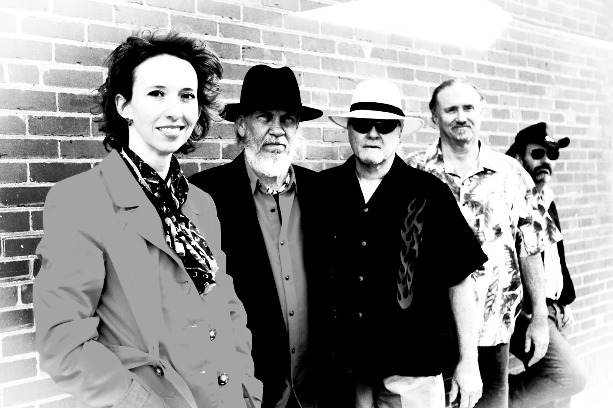 TWISTED HAMS
We take our “not-so-serious” music seriously!
An El Paso-based rock”n”roll band that delivers a big rock show for the enjoyment of those who appreciate good rock”n”roll music. They play a brand of original music that draws on influences ranging from traditional blues, jazz, classic heavy metal, to Frank Zappa and beyond.

Nicole O’Leary –Vocals & Flute
From Miles Davis to Diana Krall, Nicole’s musical interests have influenced her singing and playing over the years. As an El Paso native, Nicole learned to play the flute and develop her love of music in high school band. She hopes to bring a unique and fun listening experience for the crowd.

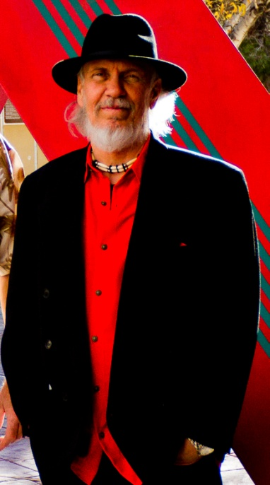
Ron Lambert – Drums & Percussion
Rondosonic, as he is known to his friends, started drumming at about twelve years of age. After playing a number of years with local musicians he spent 20 years studying and teaching martial arts. He returned to making music, thanks to band mate Paul Hyder. Ron loves the creative aspect of playing original music. Ron’s drumming style incorporates flare and grace.

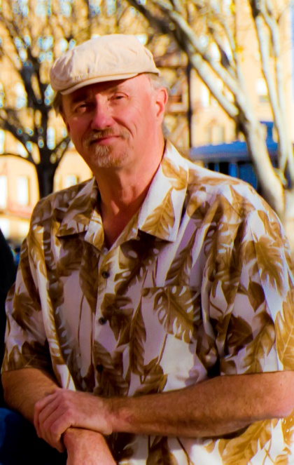
Mike McFee – Bass Guitar
Mike hails from Ohio and has been involved in music since an early age. He has lived and played music in the El Paso area with several highly respected musicians for a number of years, and currently plays in three different bands.
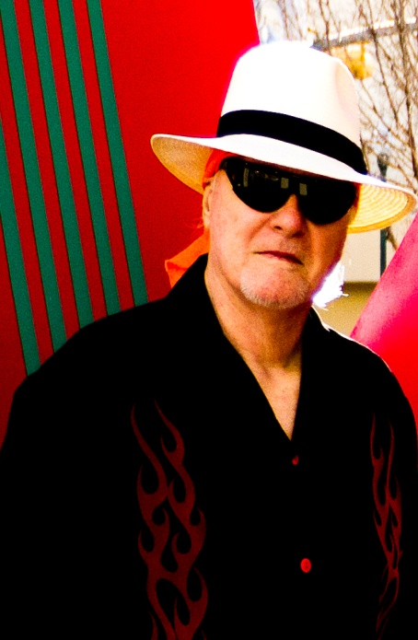
Randy Russ – Guitar & Vocals
Born in Florida, Randy moved to El Paso at a young age. One evening, instead of doing homework, Randy saw Elvis on the Ed Sullivan show. This launched him into playing Rock”n”Roll. Long John Hunter was a major influence on Randy’s playing style. Over the years, Randy has played with the Legend, Big Sonny and the Lowboys, and Russ T. Nails.

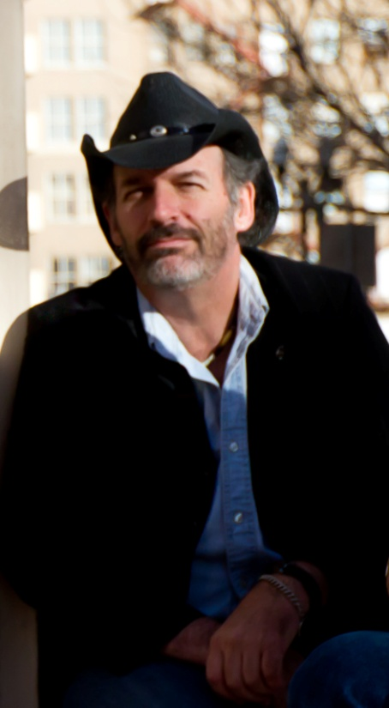
Paul Hyder - Guitar & Vocals
Paul was born in Albuquerque, New Mexico. Paul’s introduction to music, remarkably similar to Randy’s, was thanks to The Beatles. Paul played bass guitar in a number of bands before switching to guitar and forming Twisted Hams. Paul’s influences include Ritchie Blackmore, Keith Richards, Zal Cleminson, Steve Vai, Frank Gambale, and the Zappas.

